|  |  |
| --- | --- |
| Ex. No.: 14 | **SPEED CONTROL OF INDUCTION MOTOR USING**  **PI CONTROLLER AND SVPWM** |
| Date: |

**Aim**

  To design and simulate a speed controller for induction motors in EV using PI Controller and Space Vector Pulse Width Modulation (SVPWM)

**Introduction**

In electric vehicle (EV) applications, the speed control of induction motors is crucial for efficient and responsive operation. A PI (Proportional-Integral) controller is commonly employed to achieve precise speed regulation. The PI controller adjusts the motor's input voltage based on the error signal, which is the difference between the desired and actual speeds.

 The Proportional component responds to the present error, providing a control action proportional to the speed deviation. The Integral component adds a corrective action based on the accumulated past errors, minimizing any steady-state speed errors.

 The PI controller helps maintain a stable and accurate speed, enhancing overall performance and energy efficiency. This control strategy ensures that the induction motor operates at the desired speed under varying load and driving conditions, contributing to a smoother and more reliable electric vehicle experience.

**ALGORITHM**

 The algorithm for speed control of an induction motor involves setting a reference speed, measuring the actual speed using a sensor, and calculating the speed error. The PI controller adjusts the modulation index based on the speed error. This modulation index is then used in the SVM (Space Vector Modulation) block, which generates three sine waves 120 degrees out of phase to represent reference voltages for the motor phases. A repeating sequence block ensures the cyclical and repetitive nature of the SVM output. Relational operators compare SVM output with a carrier signal to determine gate pulses for a three-phase inverter. These gate pulses control the inverter switches, modulating the voltage applied to the induction motor. The closed-loop system continuously adjusts the modulation index via the PI controller to minimize speed error, resulting in precise speed control of the induction motor.

**BLOCK DIAGARAM**

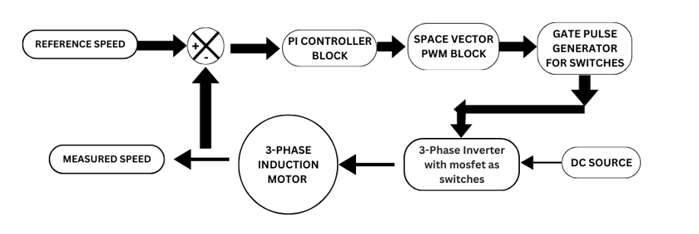

**CIRCUIT:**

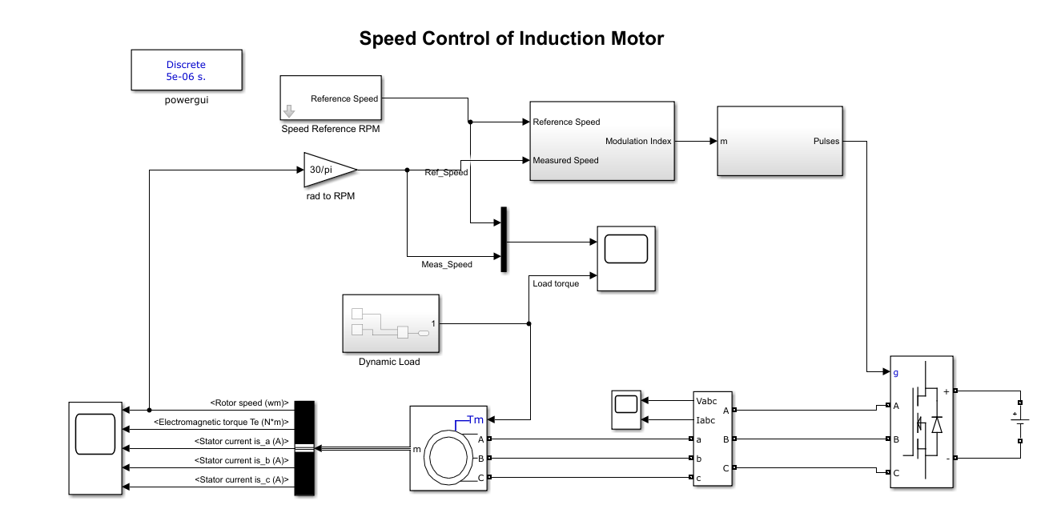

**WAVEFORMS:**

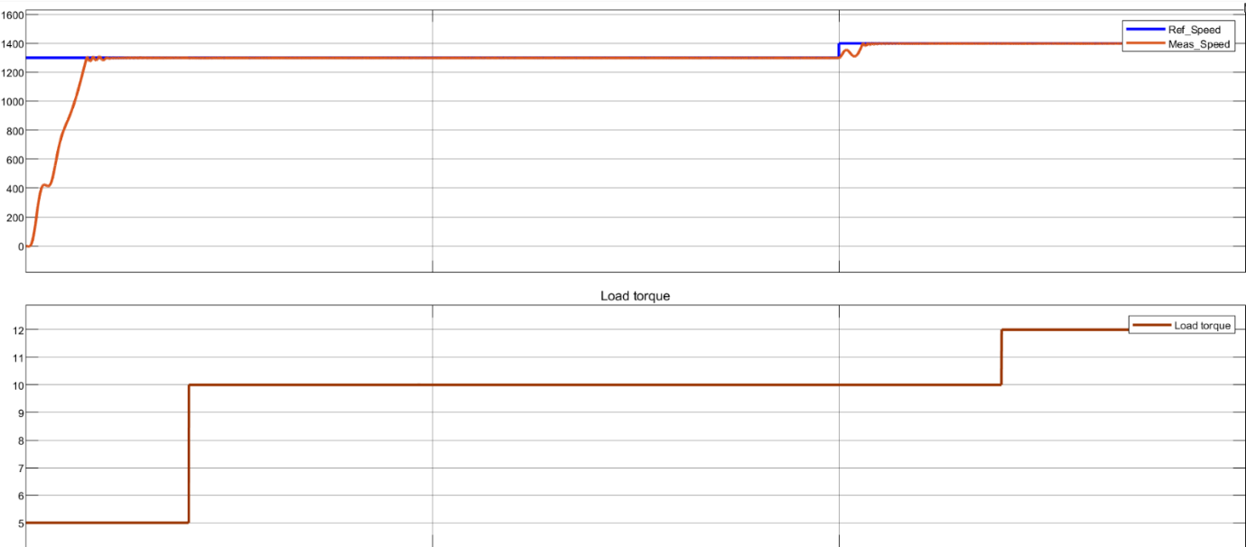                    **Fig.1:** Plot of reference speed and measured speed for different load torques.

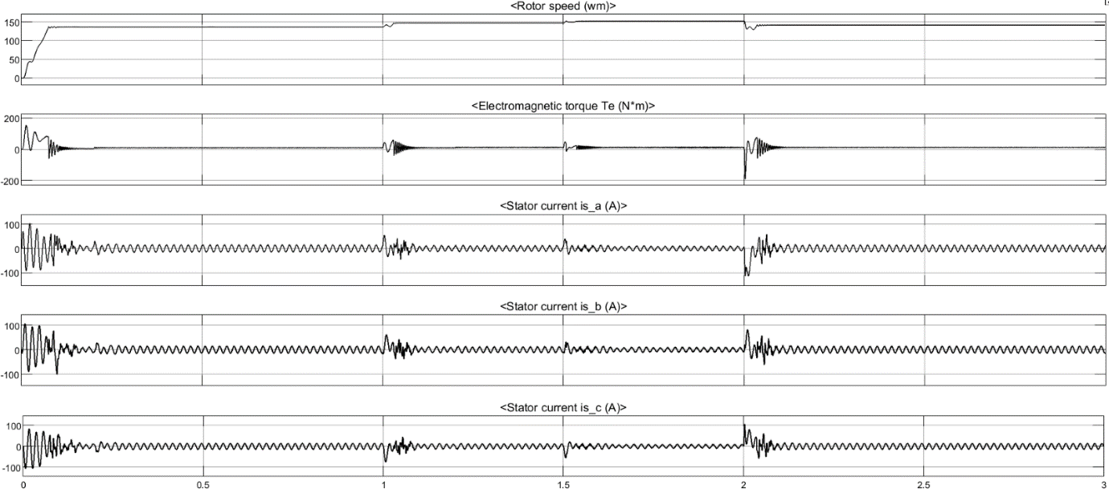

**Fig.2:** Plot of stator currents and Electromagnetic Torque

**INFERENCE**

 The simulation shows that the motor responds well to changes. The actual speed closely follows the desired speed, indicating effective speed control. The load torque graph illustrates the motor's ability to handle different loads smoothly. In summary, the simulation confirms the reliability of the control system for maintaining accurate motor speed, even with dynamic load variations.

**RESULT**

Thus, the design and simulation of the speed controller for induction motors for EV application is simulated using Simulink.